Cheryl Liao

Assignment #3

CSC382: Applied Image Analysis

**Problem 1: Canny Edge Detector and Hough transform:**

A.

1. An edge here represents the enclosing boundary of a distinct object, be it a house, shrub, or tree.

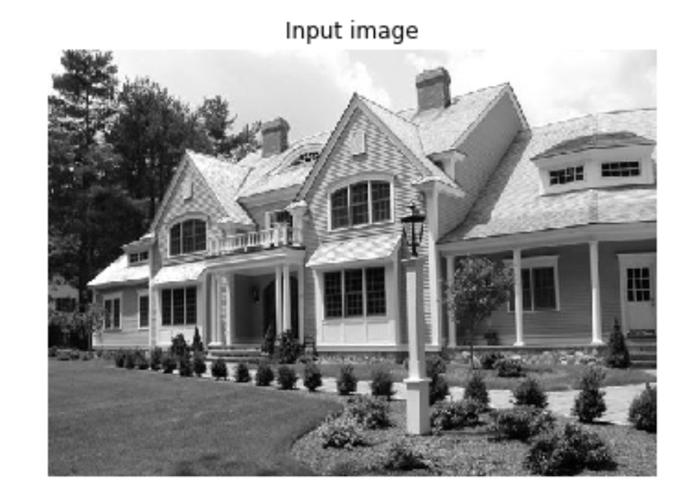

1. By computing the median of the image, we calculated the lower and upper thresholds using standard deviation of 0.3, a standard agreed upon by statistics for a 68% confidence interval, then used those values in the OpenCV canny edge detector. The outputted image is really inclusive of all possible edges in the image.

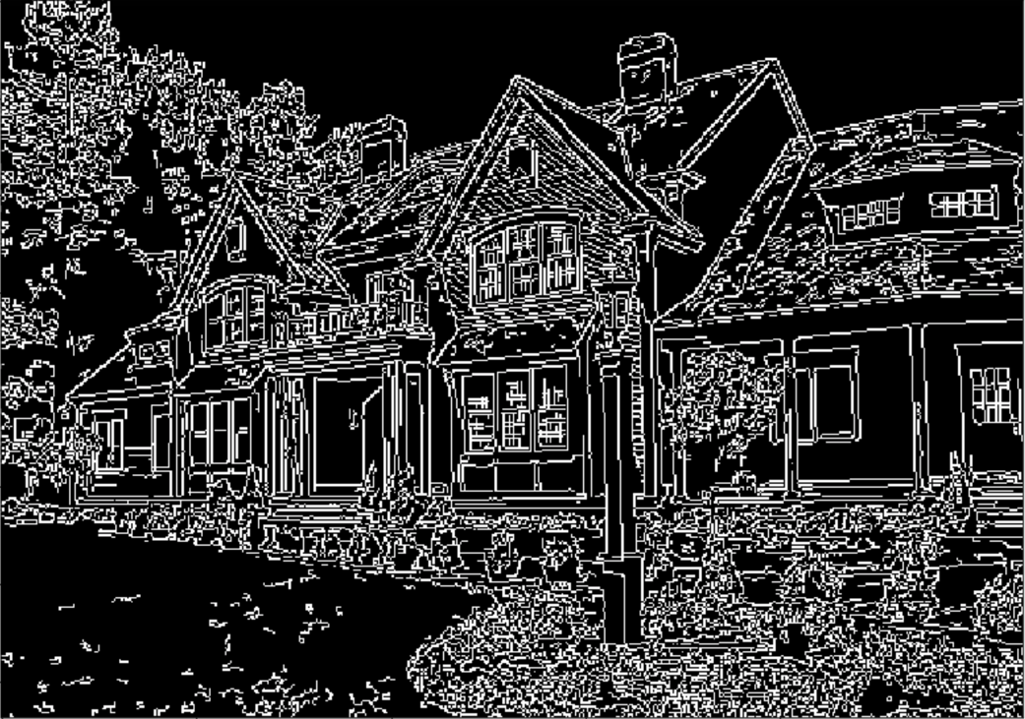

B. a) A position in the Hough space corresponds to a vote of a possible line in an image.

b) Hough Transform output image:

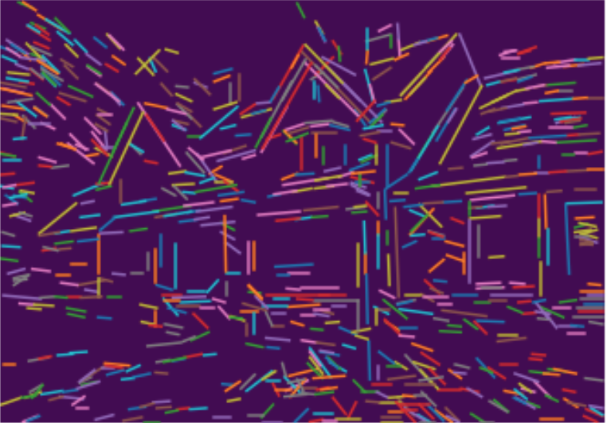

Majority of the house is detected, except for details of the window panes.

c) In this case the parameter for line length is set to 10, so anything shorter than that is not detected.

**Problem 2:** **Fourier transform**

**Differentiating between different types of images using energy distributions:**

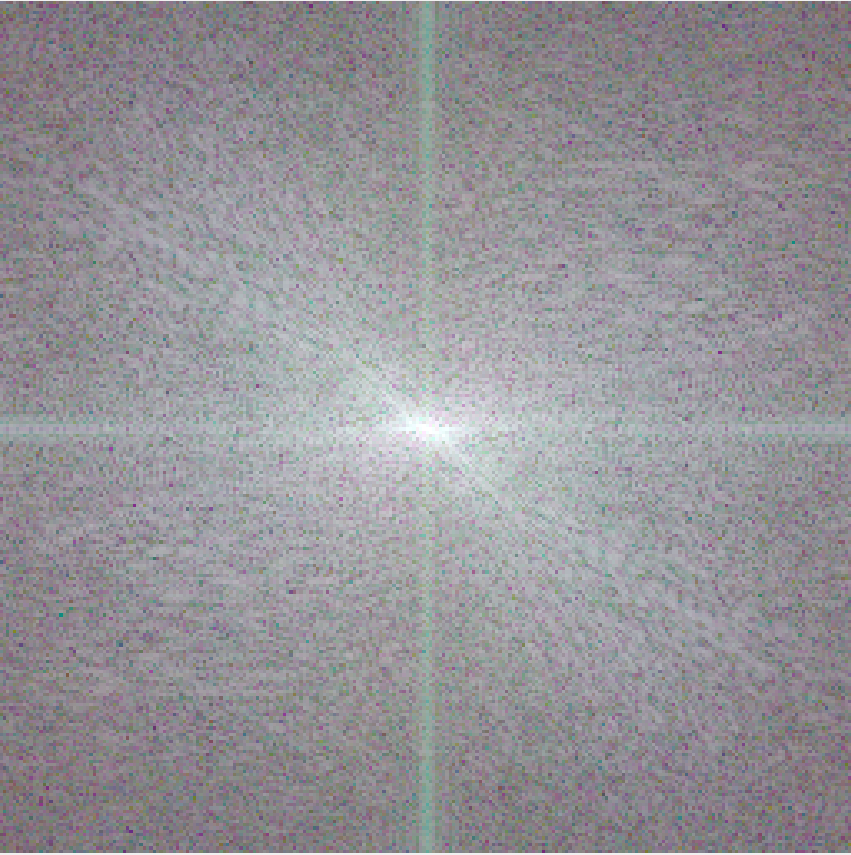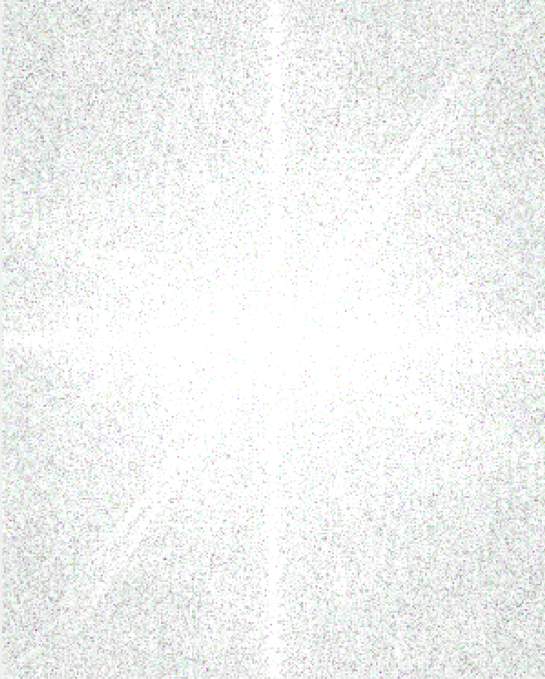

Natural on the left vs. Diagram on the right

1. As can be seen, the diagram has a hazy spectrum due to its lack of real edges and contrast, while the natural image of Lena has a distinct spectrum.
2. Fourier transform is very useful in the field of radio astronomy to invert signals into actual images of the far away sky. In a paper I found from MIT, a proposal is made to convert large analog dish telescopes to square digital ones based on FFT for astronomy, the technology is called 21cm tomography. It proposes the mathematical methods to transform the sky view into 2D views, which is slightly modified from its analog predecessor. The paper also discusses computing cost based on the matrix layout of the sensors in the square grid. It goes into detail the analysis of the proposed new telescope in its sensitivity, field of view, cost, how much further out it can view the sky. However special construction must be taken into account for correct operation. All in all the design saves cost while providing magnitude larger field-of-view.

**References**

[1] Max Tegmark, Matias Zaldarriaga “the Fast Fourier transform Telescope”, Dept. of Physics & MIT Kavli Institute, Massachusetts Institute of Technology, Cambridge, MA 02139, Center for Astrophysics, Harvard University, Cambridge, MA 02138, USA

Extra Credit:

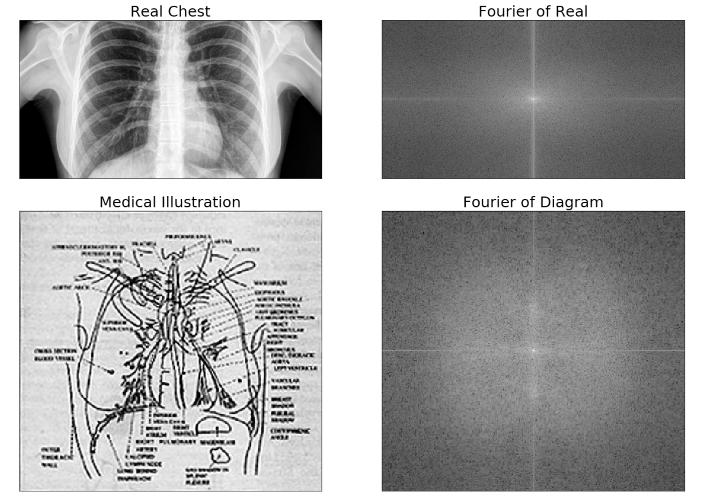

As demonstrated, the same results are obtained for comparing a real chest x-ray to an illustration; the Fourier of the real image shows more concentrated and sharper contrast than the diffused, hazy Fourier of the illustration; it is a good technique to use for filtering out real images from artificial ones.

**Problem 3: Fourier transform: frequency spectrum:**

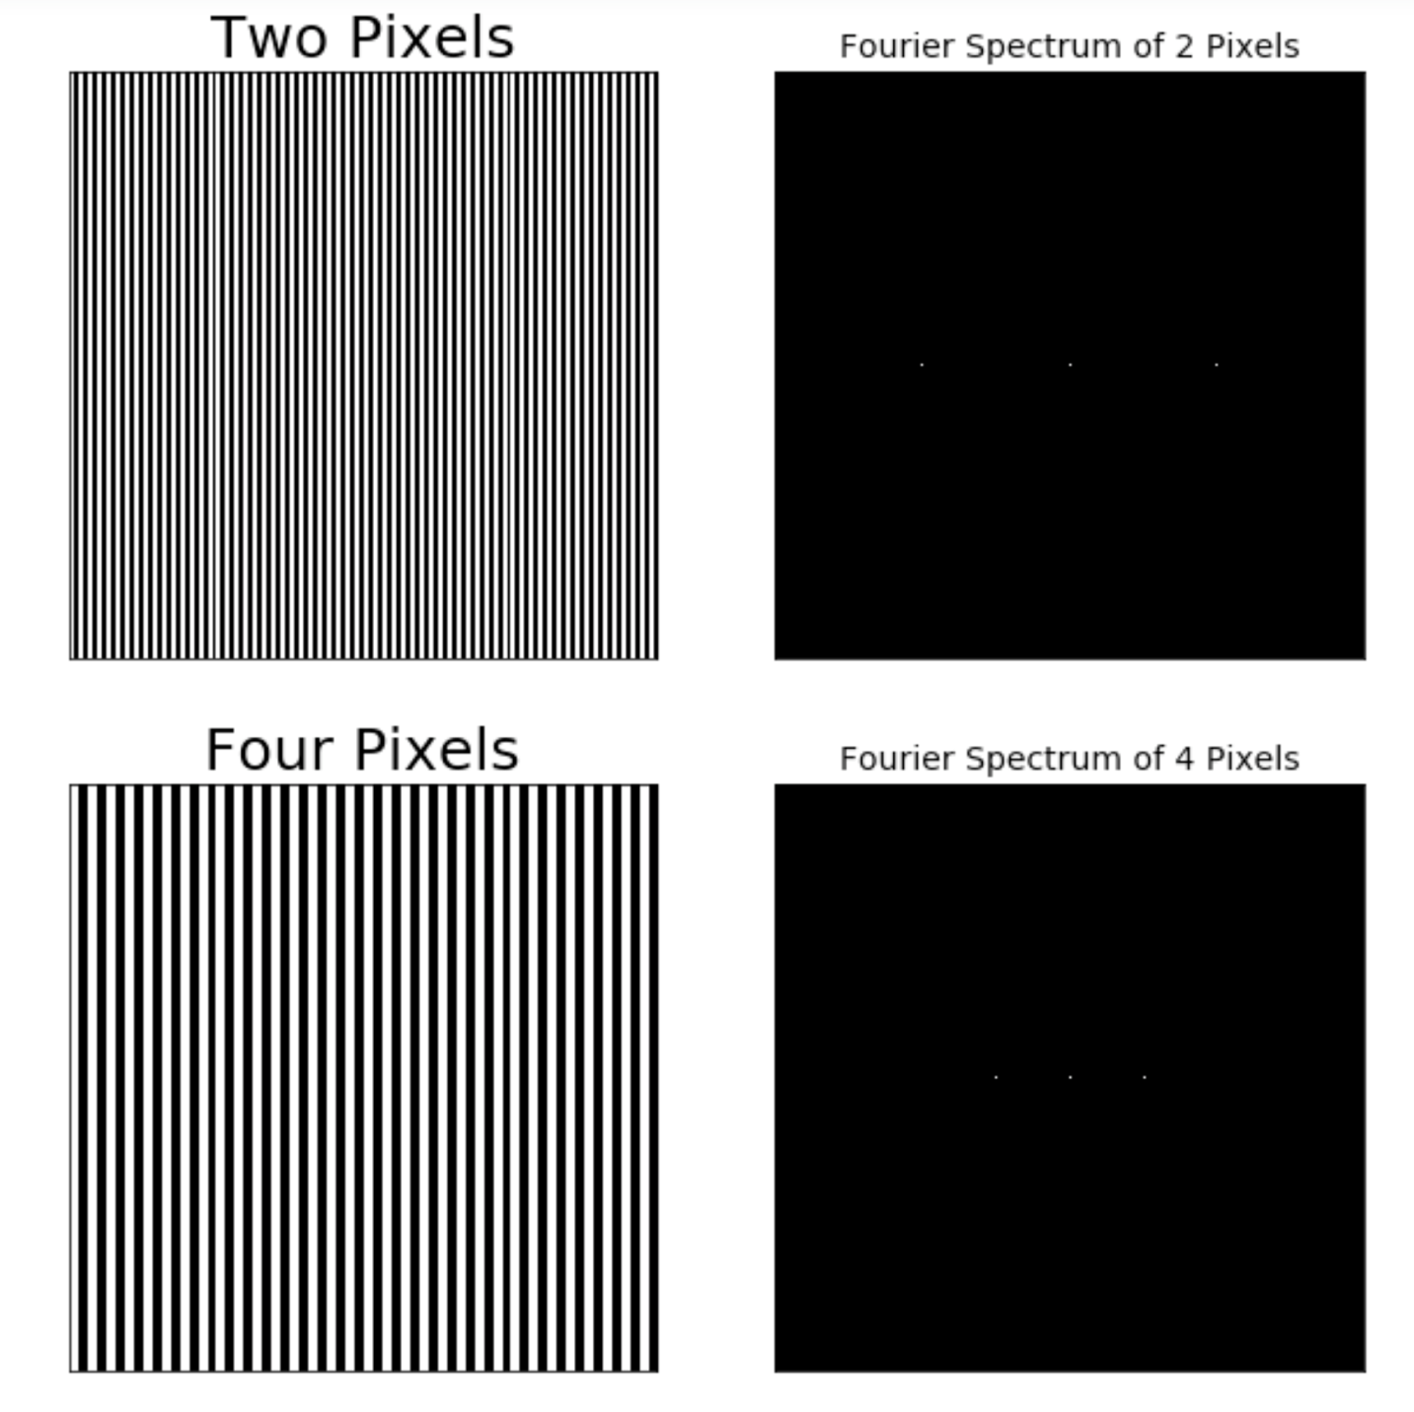

Four pixel wide strips produce an image with slower change in respect to the frequency domain; therefore, lower frequency gives lower values of FFT that is closer to the DC term at exactly two factors closer, since the width of the variations increased by two. As the graph illustrates the comparison.

b. The Fourier transform measures intensity changes, in the original image there is only changes going in the horizontal direction, since the stripes are vertical, so there are only horizontal components in the frequency domain.

c. the spectrum would have a single dot in the middle because the if the stripes are only one pixel wide, the other two horizontal component beside the zero DC component would be twice as father away from the center as the image for the stripes that are two pixels wide, and according to the frequency spectrum shown in the problem they would most certainly fall out of view; which is to say that the stripes are almost too small for a change to be detected. As the following produced by Python code illustrates:

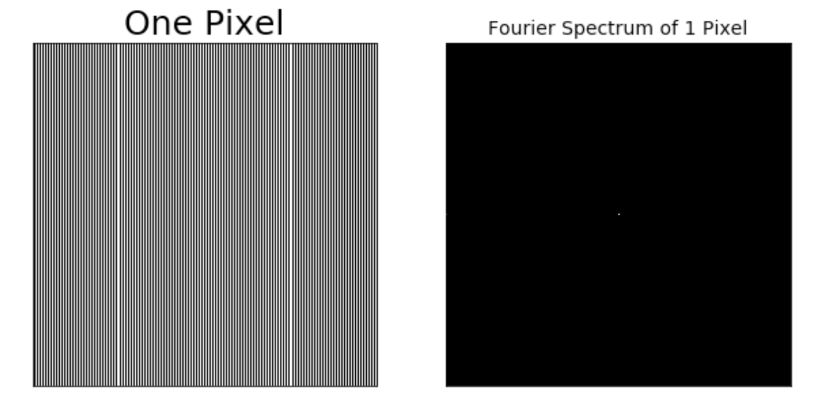

d. The DC term is the 0 Hz term and is equivalent to the average of all the samples in the window. The DC terms are the same in both a and c because the average of all the samples is simply the average between the black and white pixels, regardless of pixel widths.

**Problem 4: 1-D Haar transform:**

a.

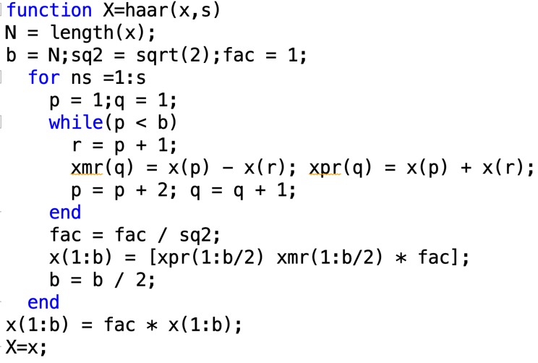

b.

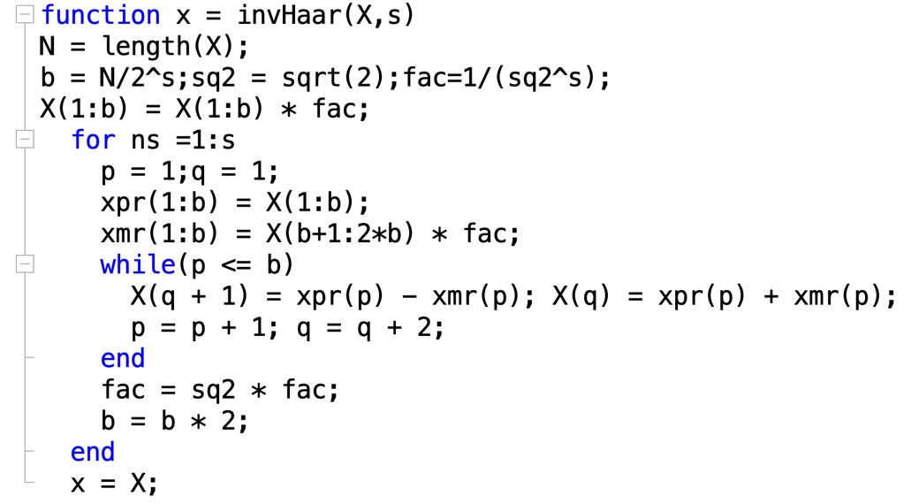

c. Screen shots of using the Haar transform function then invert it using the array from example 6.19 [1,4,-3,0]:

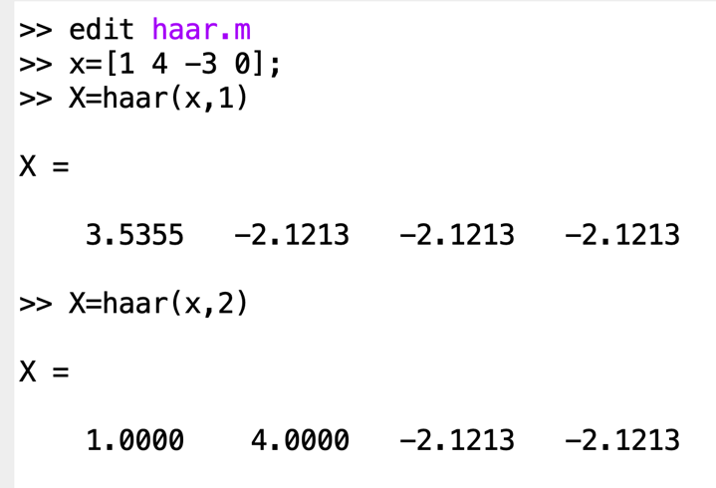

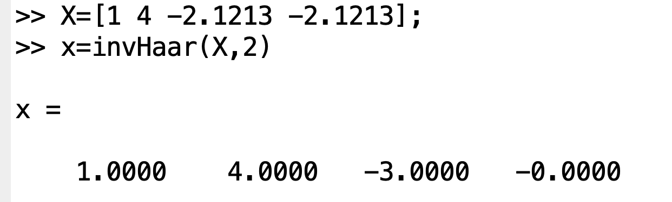

1. Below is the visual representation of the noisy signal produced using the MATLAB function:

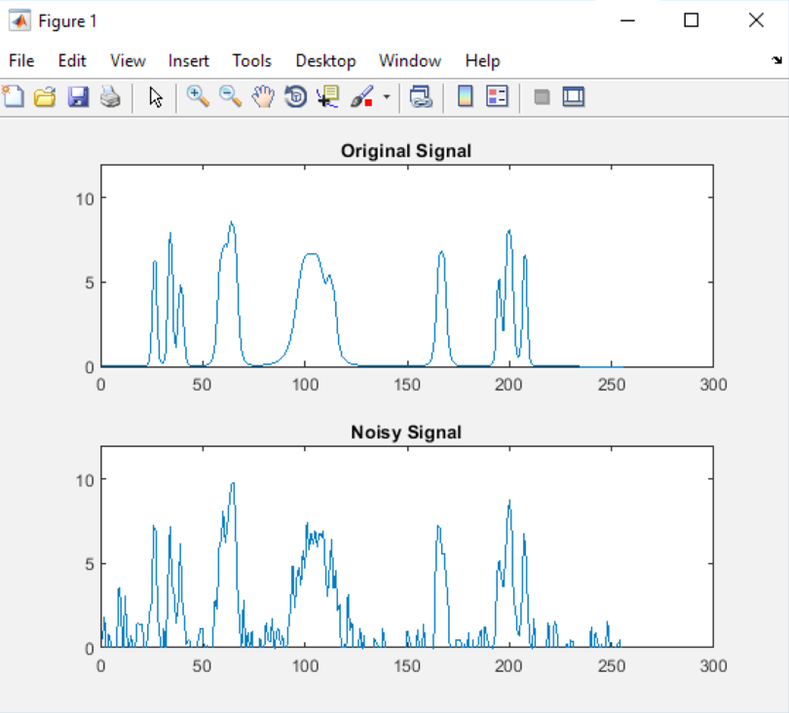

Below is the comparison of the signal after denoising and inverting back from Haar wavelet transform. As shown the signal is less noisy:

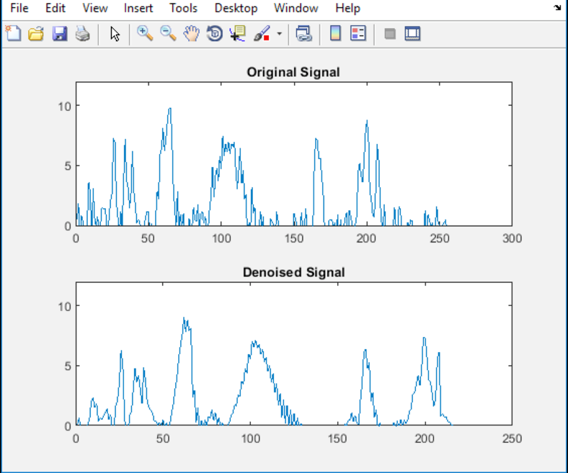

1. Inputting an N=8 vector, putting it into the Haar transform then invert it back to its original array.

